SAVEETHA SCHOOL OF ENGINEERING
SAVEETHA INSTITUTE OF MEDICAL AND TECHNICAL SCIENCES
INSTITUTE OF CSE
CSA15- CLOUD COMPUTING AND BIG DATA ANALYTICS
LIST OF EXPERIMENTS
7.Create a simple cloud software application for Students Attendance System using any
Cloud Service Provider to demonstrate SaaS include the necessary fields such as name
of the students, course, present , Absent, course attendance, OD request, grade,
attendance percentage, etc.
INPUT:
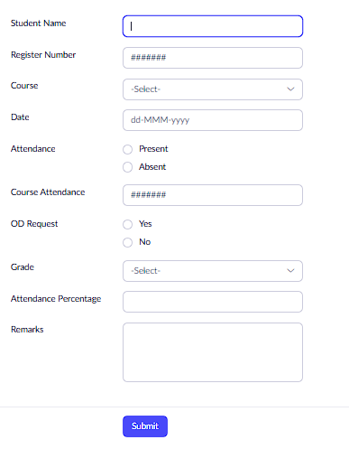

OUTPUT:

